DevOps Project
CI/CD Pipeline for an Agricultural Market Price Tracker
Task 03: Requirements, Architecture and Technology Setup
Name: Aditi Gawari
Branch: CMPN | Division: A
Roll No: 23102A0025 | Batch: 1

- Technology Stack
Layer | Choice | Why
Language/runtime | Java 21 | LTS, matches local JDK, widely supported by Jenkins/Tomcat tooling
Framework | Spring Boot 3.x (Spring MVC + Spring Data JPA) | Fast to scaffold CRUD + REST, standard for Maven/Tomcat DevOps pipelines
Build tool | Maven | Most common pairing with Jenkins "Maven project" jobs (Task 7); clear pom.xml for artifact archiving
View Layer | Thymeleaf (server-rendered HTML) | Simple dashboard pages without a separate frontend build/deploy step
Database | H2 (file-based) for local/dev; MySQL profile for CI/prod-like deploys | H2 needs zero setup for local dev; MySQL is realistic for the Docker/Ansible stages later
Deployment target | Tomcat (WAR deployment) | App is built as a WAR and dropped into Tomcat's webapps/ , matching Task 8's explicit Tomcat/Nginx choice
Test automation | Selenium WebDriver + JUnit, run via Maven ( mvn test ) | Required by Task 9/10
Container | Docker, Tomcat base image | Required by Task 13/14
Config management | Ansible (chosen over Puppet — agentless, YAML, lower setup cost for a solo/local target node) | Required by Task 7/8
CI/CD orchestrator | Jenkins, Jenkinsfile (pipeline-as code)

- Software Requirements Summary (SRS)
  - Purpose
The system will provide a centralized web application for recording, viewing, searching and analyzing agricultural market prices. It will also serve as the application for demonstrating an automated DevOps lifecycle.

  - Scope
The MVP will include:
- Adding agricultural commodity price records.
- Displaying stored records in a dashboard.
- Searching and filtering by crop, market, date and status.
- Calculating latest, minimum, maximum and average prices.
- Viewing detailed information for individual records.
- Displaying predefined high/low price exceptions.
- Exposing REST APIs.
- Providing an application health endpoint.
- Supporting automated testing and containerized deployment.

  - User Classes
User class | Permissions in the MVP
Market staff | Enter price records
Farmer/trader | View and search price records
Analyst | Review summary indicators and exceptions
Developer | Develop, test and maintain code
DevOps engineer | Build, deploy and validate releases

2.4 Functional Requirements
ID | Requirement
FR1 | System shall allow an authorized user to create a price record for a market/commodity/date
FR2 | System shall allow an authorized user to edit an existing price record
FR3 | System shall allow any user to search price records by market, commodity, and date range
FR4 | System shall display paginated, sortable search results
FR5 | System shall compute and display today's average/modal price per commodity
FR6 | System shall compute and display % price change vs the previous reporting day
FR7 | System shall allow drill-down from a summary indicator to its underlying records
FR8 | System shall display full price history for a given market+commodity pair
FR9 | System shall flag a record as an alert when its % change exceeds a configurable threshold
FR10 | System shall flag a market as an exception when it has not reported by a configured cutoff
FR11 | System shall provide a dedicated alerts/exceptions view

  - Non-Functional Requirements
ID | Requirement
NFR1 | Dashboard/search responds in < 2s with MVP-scale seed data (local testing)
NFR2 | All write endpoints (create/edit) require an authenticated, authorized role
NFR3 | Application is packaged as a single deployable WAR artifact
NFR4 | Application is container-runnable with no code changes (Task 11/12)
NFR5 | Target environment is reproducible from a clean node via Ansible, idempotently (Task 13/14)
NFR6 | All critical user journeys are covered by automated Selenium tests gating deployment (Task 9/10)

- Use-Case Diagram

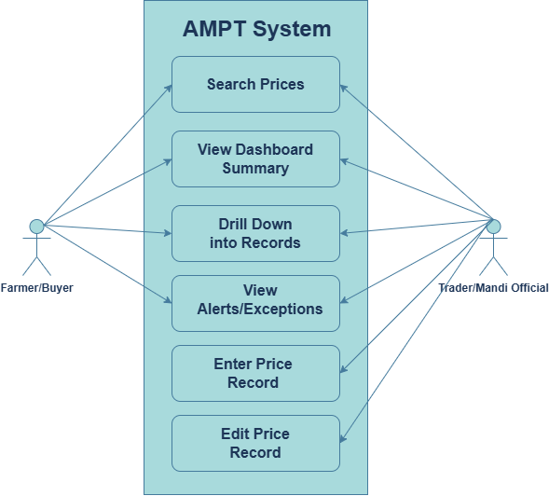

- Application Architecture

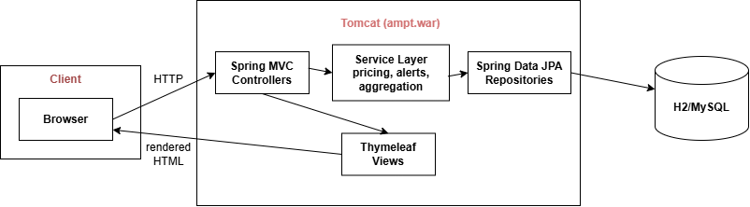

- Data Model (ER Diagram)
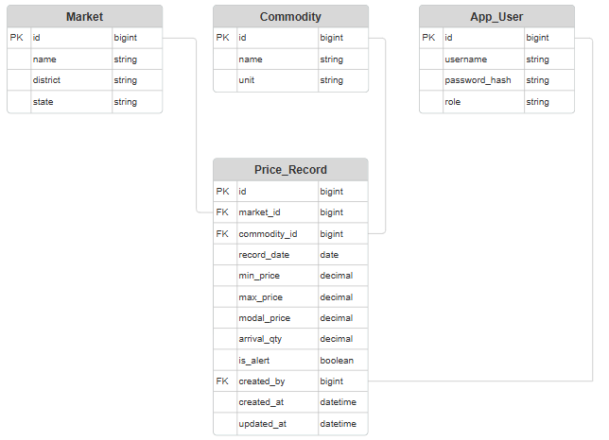

- API List
Method | Endpoint | Purpose | Auth
GET | / | Dashboard (summary indicators) | Public
GET | /prices | Search/list price records (query: market, commodity, from, to, page, sort) | Public
GET | /prices/{id} | Single record detail (drill-down) | Public
POST | /prices | Create a price record | Role: ENTRY_USER
PUT | /prices/{id} | Edit a price record | Role: ENTRY_USER
GET | /dashboard/summary | JSON: avg/modal price, % change, markets reporting | Public
GET | /alerts | List active alerts/exceptions | Public
GET | /markets | List markets (for form dropdowns) | Public
GET | /commodities | List commodities (for form dropdowns) | Public
GET | /actuator/health | Health check (used by Ansible/monitoring in Task 14) | Public

- Local Development Setup
